Wausau Pro Musica
September Newsletter
Can’t wait to get back into our music room!
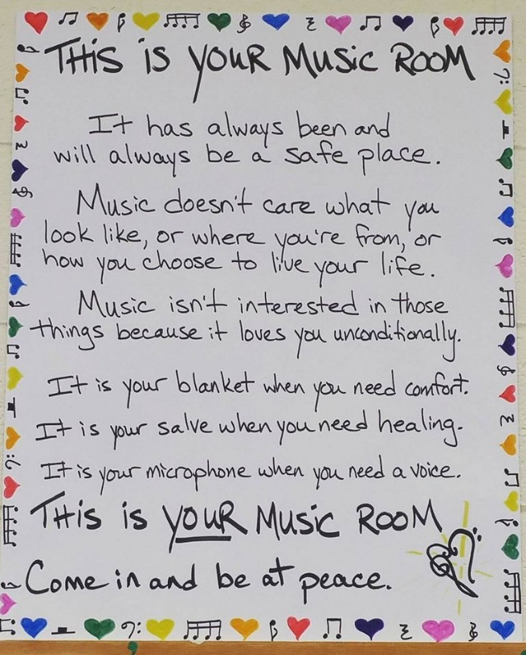
by Dixie Hettinga & Karen Zuidema 9/4/20

Board President’s Notes:
At the September 1st Board meeting, we approved an updated trifold with background information on our organization; this will be sent in some of the envelopes for our letter writing campaign targeted for the middle to end of September. The pictures used at this time include Judy and Karen is OK with that; we will work on getting updated pictures as soon as we can.
The strategic plan with revised goals was updated; I am just including the 6 and 12 month goals in this Newsletter. The vision statement, mission statement and core values all remain the same.
6 month goals (February 2021):
· Assist Karen in orienting to the organization as our new Artistic Director
· Continue to monitor CDC and government regulations and prepare to resume rehearsals when safe to do so; may need safety protocols in place
· Continue monthly Board meetings and monthly membership meetings via zoom; membership meetings to be structured with invitation/agenda sent out prior to the meeting
· Plan for second annual signature fundraising event; oversee Committee plans for karaoke fundraiser at Whitewater slated for Spring 2021
· Mentorship program continued; include mentees in monthly zoom meetings
· Utilize our website and facebook page for marketing and name recognition
· Oversee letter-writing campaign fundraising and recognize contributors on our website
· Update the website to allow direct contributions by credit/debit card

12 month (August 2021):
· Resume rehearsals when safe to do so; may need safety protocols in effect
· Assist Karen in orienting to the organization
· Target rehearsal techniques to improve vocal ability, musical artistry and blending as a choir after not being able to physically meet together for almost a year
· Hold second annual signature fundraising event targeted for Feb/March 2021
· Hold Spring concert if safe to do so
· Increase number of singers to 40
Promote group to potential singers through word of mouth and website
· Increase exposure in the community—more run-out concerts
Have available repertoire for ALFs/nursing homes
Consider opportunities such as Woodchucks or other team events

We would like to invite the entire membership to a zoom meeting on September 15 from 6:00 PM - 7:00 PM. The meeting will include some socialization and re-connecting, some instruction/education and some fun!! We are targeting a different section each zoom meeting and will start with the Alto IIs; if you are an Alto II, please be prepared to introduce yourself as we may have a new Alto II joining us and some new mentees, or just give an update on how your summer went, recap any trips, etc. I will send the invitation out the Monday before the meeting.

PLEASE, PLEASE, PLEASE return your binders with the Spring music if you have not already done so. These should be returned to the WCM and placed in the box by Debi Traeder’s office. The library committee is hoping to file that music (and clear some space on our office table !!) in the next month. Donna is remaining as Chair of that committee right now but has some health concerns that prohibit her from physically assisting. If you cannot drop your music off, please contact Dixie and I would be more than happy to pick it up. I picked up Charlotte’s music this past Wednesday and she is looking great!!

Also, please continue to remember in your thoughts and prayers those who have recently lost loved ones: Shelly, Mary, Linn, Cyndi. For those of you who have lost loved ones in the past, you know it can take a long time to heal and the road to recovery can be very difficult. Charlotte and Donna have ongoing health needs and Jeannie Russell had heart surgery this past Tuesday. I’m sure they would appreciate an email, a card or phone call.

Looking forward to seeing many of you on the 15th!!

Artistic Director’s Notes:
Hello Pro Musica! There’s not a lot new information to bring to you since the August newsletter, so I thought I would share a wonderful TED Talk instead. After watching an interesting TED talk about how menopause affects the brain (sigh) I started poking around the TED site and found an amazing 10 minute talk by Arreon Harley; the director of music at the Choir School of Baltimore. Your assignment (should you choose to accept it): take the time to watch this on Youtube. The link is below - it will take you to the correct video. If it doesn’t - search “Arreon Harley: How Choirs Have the Capacity to Change Lives” and it will pop up. If you don’t have time to watch the entire 10 minute talk - you really need to see at least the 2nd half; fast forward it to the 4:17 mark (No, not Mark 4:17 - that’s the Parable of the Sower).
Key points that I love:
- I’m human and I’m going to make mistakes (so will the others around me). Choir is a SAFE spot.
- There is no such thing as a perfect performance
- The idea of perfection is still worth the pursuit.
If the music board photo at the top of the newsletter doesn’t remind you that choir is a safe place for your soul, his talk certainly will.
https://www.youtube.com/watch?v=-heVqNNqI_w

A couple of last reminders:
- I hope everyone can join us at the September 15th Zoom WPM meet. We’re going to spend a short time on some vocal warm ups. If you have a spare drinking straw around the house you can have it ready - I won’t spend a lot of time on straw phonation, but it is a great way to get those vocal folds vibrating again. I’m also planning on unrolling the Spring concert repertoire list. TADA!
- PLEASE REMEMBER TO GET YOUR FOLDERS TURNED IN!

Karen Zuidema karenazuidema@gmail.com

New Website address: www.wausaupromusica.org

