Wausau Pro Musica
November 2021 Newsletter
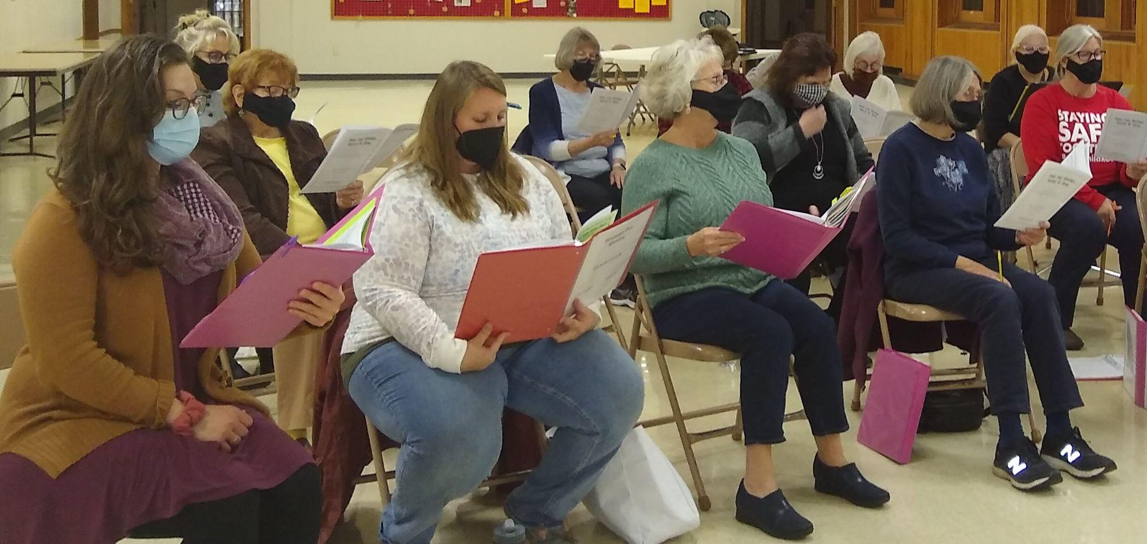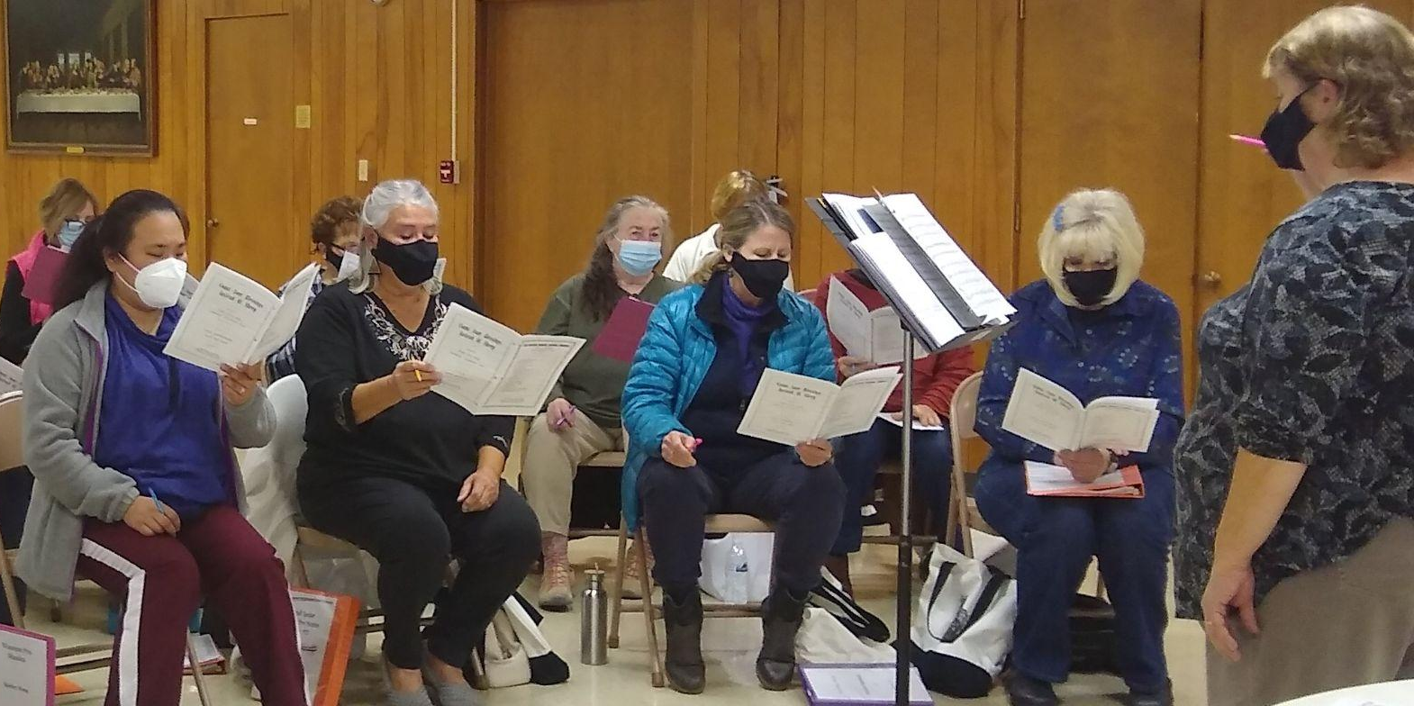
Thanks for the photos, Shelly!!!

by Dixie Hettinga & Karen Zuidema 11/11/2021

Links:
Spring 2022 Rehearsal Schedule: Pro Musica Spring 2022 Rehearsal Schedule
Link: Silent Night arr. Roger Emerson, Pentatonix
Carol of the Bells link: Media Player (jwpepper.com)
Sing Alleluia, Allelu (Goetze) Media Player (jwpepper.com)
Mary, Did You Know? : Mary Did You Know SSA - Balanced Voices

Board President’s Notes:
Highlights of the Board meeting 11-9-21:
- We continue to receive donations from our letter-writing campaign. We received a memorial donation from Charlotte Hoecker’s family.
- Jan Dahlke and Patti Gillette have had to withdraw from membership this Fall.
- The spring rehearsal schedule was approved; we will poll the members to determine whether to have one or two concerts in May of 2022. Venue to be determined. The rehearsal schedule is subject to change depending on COVID cases in our area.
- Our current COVID protocol will remain in effect for the Spring semester with continued use of masks and social distancing. Proof of vaccination is required and Barb is still tracking those down. We will re-institute the attendance policy for the Spring semester (2 excused absences); however the attendance policy will be applied more loosely and members will be encouraged to stay at home even if they are mildly ill. Determination of whether a member who has missed more than 2 rehearsals can participate in the Spring concert is at the discretion of the Artistic Director. We will reach out to previous members who elected not to participate this Fall to ascertain whether they will rejoin for Spring.
- We cancelled the December 7th rehearsal. We will have a Board meeting that evening and will approve the 2022 budget.
- Run-out concert is still on for 1:30 PM on Dec 4th at Primrose. Karen is finalizing the itinerary. Call time 1:00 PM.
Since I am also helping with the library committee, please be prepared to hand in your rehearsal binders at the Tuesday rehearsal on November 30. You should have all concert music transferred to your performance folders by then. If you will not be singing at Primrose, hand in all your music on November 30. For those of you singing at Primrose, your concert music will be collected immediately afterwards. PLEASE ensure you return your rehearsal binder so we can prepare it for the Spring semester.
I totally agree with what Karen says below. What a road it has been to get back to full rehearsals! And while wearing masks and social distancing is not ideal, at least we get to make music again together. We have continued to support and encourage one another through it all and realize we have so much to be thankful for and will be stronger for it. May you and your families have a blessed Thanksgiving!

Artistic Director’s Notes
It was so great to hear everyone singing together on Tuesday. Along with all of the laughter, I have to admit I had a couple of moments when I was also close to tears - hearing the beautiful harmonies ring through that space was truly an emotional blessing. All the hurdles that the choir has had to face since the Covid outbreak started could so easily have distracted us from remembering why we chose to be here. Starting full rehearsals again brings that purpose back to the forefront - to sing and share our song.
If you haven’t checked your calendars recently, please do so soon. It would be good to get a full head count on how many we know will be joining us to sing on December 4th at Primrose. We’ll be asking you to let us know if you will be joining us or not at the Tuesday, 11/16th rehearsal. If you aren’t able to join us at Primrose, please DO continue to come to our Tuesday rehearsals. We want everyone back in full, healthy voice so we can have you all ready to go in January. Also at our next rehearsal - we would like to take a poll on how you feel about having 2 spring concerts in May - (Friday May 6 and Sunday May 8) or to have one concert as has been traditionally done for the spring (Friday, May 6). Please realize as you are considering this decision that May 8th is also Mother’s Day. One more note about rehearsal schedules - we are not meeting for rehearsal on Dec.7th. Our next rehearsal after our run out performance will be in the beginning of January.
Speaking of….included in the links at the top of the newsletter is the Spring rehearsal schedule. As stated in the schedule, please remember that things may have to change as Covid news in our area changes. Also - the concert information at the end of the schedule is tentative depending on our decision concerning doing a single concert or two. I’ve also included links of performances of some of the music that we will be singing at Primrose - since we don’t have choral tracks for this semester it’s always good practice to rehearse your part with a recorded performance. See you soon!

Karen karenazuidema@gmail.com

New Website address: www.wausaupromusica.org

