Wausau Pro Musica
August 2022 Newsletter
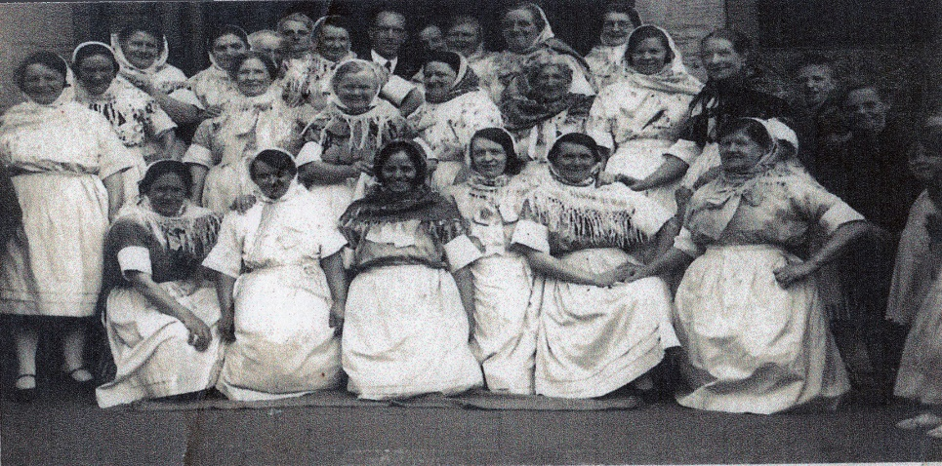

This Photo by Unknown Author is licensed under CC BY-SA-NC
by Kathy Koch-Engstrom & Karen Zuidema 8/12/2022
Important Links You Need:
Audition flier: Attention.docx
2022 1st semester rehearsal calendar: ProMusica Winter 2022 Rehearsal Schedule
2022 Winter concert order: Pro Musica Winter 2022 Program
2022 Winter concert music scans, choral tracks and examples to watch or hear: ProMusica Winter 2022 Music scans, choral tracks, examples to watch

Everyone please note: our first rehearsal listed on the schedule is on September 6th, which is actually set up for voice blending. You will only need to come in for the time that your section is listed. Please try to be there a few minutes early so that we can start your group right on time. Once we get the section blended Shelly will have some paperwork for you to go through and sign - then you are free to leave!
Board President’s Notes:
Hello Ladies of Pro Musica!
Good summer wishes to all and a warm welcome back to our 2022 - 2023 exciting season of song together!

Your WPM Board of Directors met Tuesday, August 2nd for a jam packed three hours of discussion, planning, tossing around of ideas and camaraderie, as we prepare for another fantastic season of making music together.

Below you will find bulleted highlights from the meeting and updates to be aware of as we enter our new semester of rehearsals and concerts. More detailed information will be available on our Pro Musica website in approximately two weeks. You will also find attached the minutes from the board meeting, Karen’s Artistic Directors notes and fall schedule for rehearsals.

There were a few changes within our board member positions as we enter this semester. But first, a huge thank you to Dixie Hettinga for her service to the choir as Board President for the last six years – she served and guided this choir with thoughtfulness and dedication (especially through the challenging years of COVID)! Dixie, your leadership has been extraordinary! We thank you for your years of outstanding service!

Board Member Information and Updates:
- Elected President: Kathy Koch-Engstrum
- Elected Vice President: Kris Porter
- Treasurer: Wendy Galbraith
- Secretary: Jeannie Hagenbucher
- Publicist: Shelly Kafka
- Artistic Director: Karen Zuidema
- Members at Large: Liz Corbett and Deb Traeder
- Ex Officio – Dixie Hettinga

Informational Choir Notes:
- Our Pro Musica Handbook is in the process of being updated and will be available to all in the very near future.
- Committees for choir operations are set with a new addition of Membership Coordinator – Headed by Kris Porter who will oversee attendance, updating choir roster amongst other duties. We are always looking for people to join the committees to support the choir, share ideas and talents. If you are interested, please talk with a Board Member!
- Dues will remain at $35.00 a semester – if this causes financial hardship, please see our treasurer, Wendy, for assistance.
- Our fundraiser team is in the process of finalizing the letter for our Fall Fundraising campaign.

Attendance:
- The attendance policy will be reinstated this year – members are expected to be present at each rehearsal, with dress rehearsals, recording sessions and concert performances mandatory.
- Members should not miss more than two rehearsals.
- If you are mildly ill or ill you should not attend rehearsals and contact the Membership Coordinator, Kris Porter before scheduled rehearsals.
- If you need to miss a rehearsal in person a Facebook opportunity will be available for you to participate in and will not be considered unexcused. Attendance will be taken for those occasions when attending rehearsals via Facebook, this insures remote rehearsal attendance is recorded properly.

COVID Policy:
- Masks are optional
- Vaccinations are required
- We will monitor surges in variants for Marathon County and adjust accordingly.

Feel Good Moments:
- $200.00 was donated to the St. John’s Episcopal Church towards the purchase of bells in memory of Charlotte Hoecker.
- Wausau Event Fundraiser – Wings Over Wausau this past June was an exceptional opportunity to not only make $550.00 for the choir but also to experience the generosity of the greater Wausau community through their food donations and “paying it forward” for other attendees. An immense “Thank You” to Shelly Kafka for spearheading and organizing workers – a huge task! Special thanks to all those that were able to step up and help out. The event coordinator was very grateful for our excellent support and service and would like to invite us back next year!

Please see the attached Artistic Directors notes from Karen for the Christmas music and theme along with links to choral tracks. Also find attached the Fall Schedule. It is going to be a fabulous year of singing together once again! Looking forward to seeing all of you in September!

Kathy Koch-Engstrum

Artistic Director’s Notes:
I hope everyone is having a wonderful, safe and healthy summer!
I’m really trying to keep the reading of these newsletters a bit briefer than in the past - so I’ll “just stick to the facts, Ma’ams”. But I do have to tell you all that I can’t wait to see you soon!!!

I recently sent out an email to you all asking you to please print out an informational flier about upcoming auditions. Please share this around the community, through Facebook and in conversations with your book clubs, community groups and buddy time with friends. We really would like to get our numbers back up to where we were before Covid came along. I also put the Google link for that flier at the top area of this newsletter.

Listed at the top of the newsletter is a link that has all of the information you need for each piece. If you want to get an early start - open the music scan with one tab and then open a new tab with your selected choral track. That way you can see the scan while you sing and you won’t have to print out so many pages of music (you’ll be getting the actual music in your binders at our rehearsal). The music selected for this concert was actually sent out to you in a previous year before we had to cancel due to covid, so you may already have it in a computer file somewhere. Please notice - I’ve dropped one piece that was listed last year and added the Pentatonix version of Silent Night (that we sang at Primrose) as our encore. There aren’t choral tracks for Silent Night available, but many of us already know it and we can learn it easily enough during rehearsal.

Below is the rehearsal schedule for this upcoming fall semester. The first date is not a traditional rehearsal, but a time for me to re-voice blend the choir. Please make this a priority if possible - if you do have to miss the voice blend day we can always take a few minutes at the end of our regular rehearsals and blend you into the rest of the group then - but the more that we can get accomplished before our group rehearsals get started the better. I’ll also add this schedule to the top of the newsletter as a link so you can save it and/or print it out. Our first rehearsal will also include some welcome back time and some time for announcements, questions, etc.

Schedule is subject to change due to updated Covid conditions
Pro Musica Winter 2020 Rehearsal Schedule Rehearsals will be 6:00-8:00 PM on Tuesdays.

Date | Event | Time
9/6/22 | Alto II voice matching  Alto I voice matching  Soprano II voice matching  Soprano I voice matching | 6:00 PM - 6:30 PM  6:30 PM - 7:00 PM  7:00 PM - 7:30 PM  7:30 PM - 8:00 PM
9/13/22 | Board Meeting  All member meet - welcome back!!  Soprano I & II Sectional - Alto social time  Alto I & II Sectional - Soprano social time  Full ensemble rehearsal | 5:00 PM - 6:00 PM  6:00 PM - 6:30 PM  6:30 PM - 6:50 PM  6:50 PM - 7:10 PM  7:10 PM - 8:00 PM
9/20/22 | Full Rehearsal  Break/Social Time  Sectionals  Full Rehearsal | 6:00 PM - 6:50 PM  6:50 PM - 7:10 PM  7:10 PM - 7:40 PM  7:40 PM - 8:00 PM
9/27/22 | Rehearsal | 6:00 PM - 8:00 PM
10/4/22 | Board Meeting  Rehearsal | 5:00 PM - 6:00 PM  6:00 PM - 8:00 PM
10/11/22 | Sectional Rehearsal with Section Leaders | 6:00 PM - 8:00 PM
10/18/22 | Rehearsal | 6:00 PM - 8:00 PM
10/25/22 | Rehearsal | 6:00 PM - 8:00 PM
11/1/22 | Rehearsal | 6:00 PM - 8:00 PM
Saturday - 11/5/22 | Saturday rehearsal | 9:00 AM - 12:00 PM
11/8/22 | Board Meeting  Rehearsal | 5:00 PM - 6:00 PM  6:00 PM - 8:00 PM
11/15/22 | Rehearsal | 6:00 PM - 8:00 PM
11/22/22 | Rehearsal | 6:00 PM - 8:00 PM
11/29/22 | Rehearsal | 6:00 PM - 8:00 PM
Thursday - 12/1/22 | Dress rehearsal | 6:00 PM - ?
Friday - 12/2/22 | Choir call/warm up  CONCERT | TBA  7:00 PM
Sunday - 12/4/22 | Choir call/warm up  CONCERT | TBA  2:00 PM

There may be possible run out performance also, contingent on Covid updates.
Keep well and keep singing! Can’t wait to see everyone!
Karen karenazuidema@gmail.com

New Website address: www.wausaupromusica.org

